Broken Rhyme

🔹 What is Broken Rhyme
# Source: AI Source: Provided by: [Data Path: Persons Table -> ID Column: 1, Name_En Column: Motasem Essam] -> From: [Chatgpt (GPT-4-turbo)] on [8/2/2025]
⚠️ Broken rhyme is a poetic technique, not a type of homograph.
However, homographs may appear in broken rhyme if split for rhyming effect.

✅ Definition of Broken Rhyme
# Source: AI Source: Provided by: [Data Path: Persons Table -> ID Column: 1, Name_En Column: Motasem Essam] -> From: [Chatgpt (GPT-4-turbo)] on [8/2/2025]
Broken rhyme occurs when a word is split across a line break or syllables, often to force a rhyme with another line.
It's commonly used for comic effect, surprise, or metrical rhythm.
🟥 Example:
She wanted to explore the can-
yon, though her map was wrong.
Here, "can-" is broken to rhyme with "man" or a similar word in a previous line.

🧠 Key Features
# Source: AI Source: Provided by: [Data Path: Persons Table -> ID Column: 1, Name_En Column: Motasem Essam] -> From: [Chatgpt (GPT-4-turbo)] on [8/2/2025]
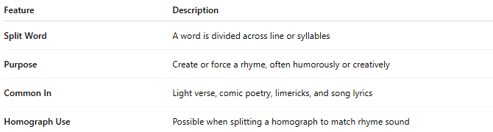
Feature | Description
Split Word | A word is divided across line or syllables
Purpose | Create or force a rhyme, often humorously or creatively
Common In | Light verse, comic poetry, limericks, and song lyrics
Homograph Use | Possible when splitting a homograph to match rhyme sound

🧪 Using Homographs in Broken Rhyme
# Source: AI Source: Provided by: [Data Path: Persons Table -> ID Column: 1, Name_En Column: Motasem Essam] -> From: [Chatgpt (GPT-4-turbo)] on [8/2/2025]
Homographs can be split for rhyme if the rhyming part matches sound:

✅ Example (with homograph “lead” /liːd/):
# Source: AI Source: Provided by: [Data Path: Persons Table -> ID Column: 1, Name_En Column: Motasem Essam] -> From: [Chatgpt (GPT-4-turbo)] on [8/2/2025]
She tried to lead the line in song
But tripped before she could go a-
head, which felt all wrong.
- "lead" = homograph (/liːd/)
- “ahead” is broken across lines → creates rhyme with “lead”

✅ Example (with “tear” /tɛr/):
# Source: AI Source: Provided by: [Data Path: Persons Table -> ID Column: 1, Name_En Column: Motasem Essam] -> From: [Chatgpt (GPT-4-turbo)] on [8/2/2025]
I saw her start to shed a tear
When thunder crashed so very near—
It hit her house and split the chan-
delier with fear.
- “chandelier” broken as "chan- / delier" → forces rhyme with “tear / near”

⚠️ Caution with Homographs
# Source: AI Source: Provided by: [Data Path: Persons Table -> ID Column: 1, Name_En Column: Motasem Essam] -> From: [Chatgpt (GPT-4-turbo)] on [8/2/2025]
Some homographs won’t work in broken rhyme if:
- Their pronunciation differs from the rhyme sound
- Splitting changes their semantic clarity
Example:
The soldier took a heavy wound
The sound of bombs a-
bound.
If "wound" is misread as /waʊnd/ (past of wind), the rhyme fails.

✅ Summary
# Source: AI Source: Provided by: [Data Path: Persons Table -> ID Column: 1, Name_En Column: Motasem Essam] -> From: [Chatgpt (GPT-4-turbo)] on [8/2/2025]
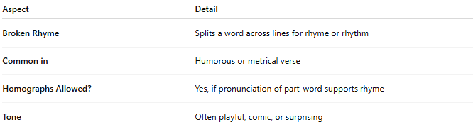
Aspect | Detail
Broken Rhyme | Splits a word across lines for rhyme or rhythm
Common in | Humorous or metrical verse
Homographs Allowed? | Yes, if pronunciation of part-word supports rhyme
Tone | Often playful, comic, or surprising

